1. Write a SQL Statement to create a database.

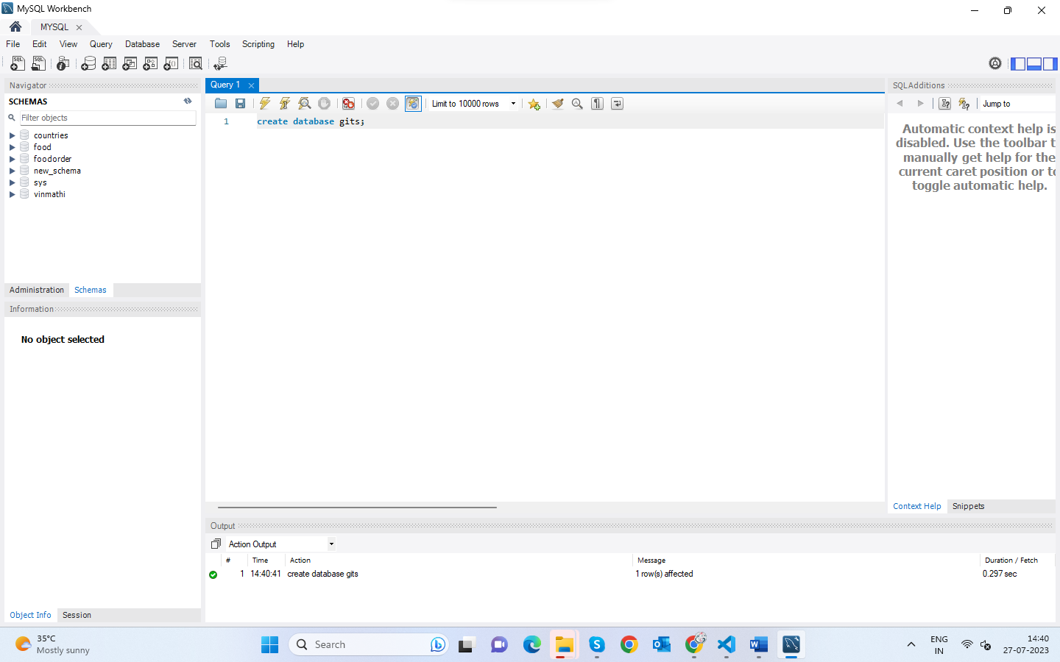

2.Write a SQL statement to create a table named countries including columns country_id,country_name, and region_id, and make sure that no duplicate data against column country_id will be allowed at the time of insertion.

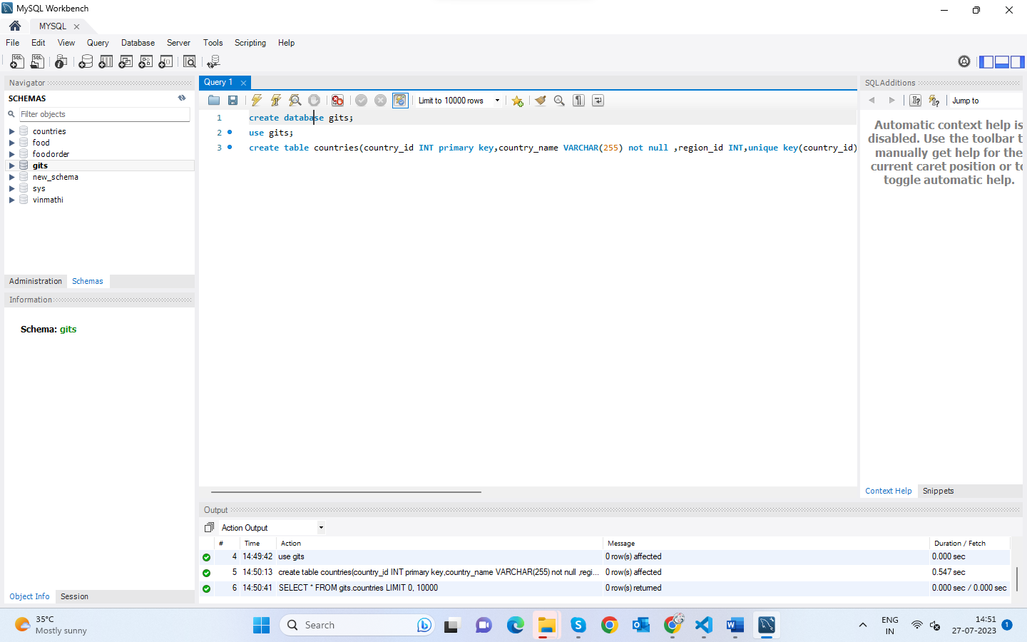

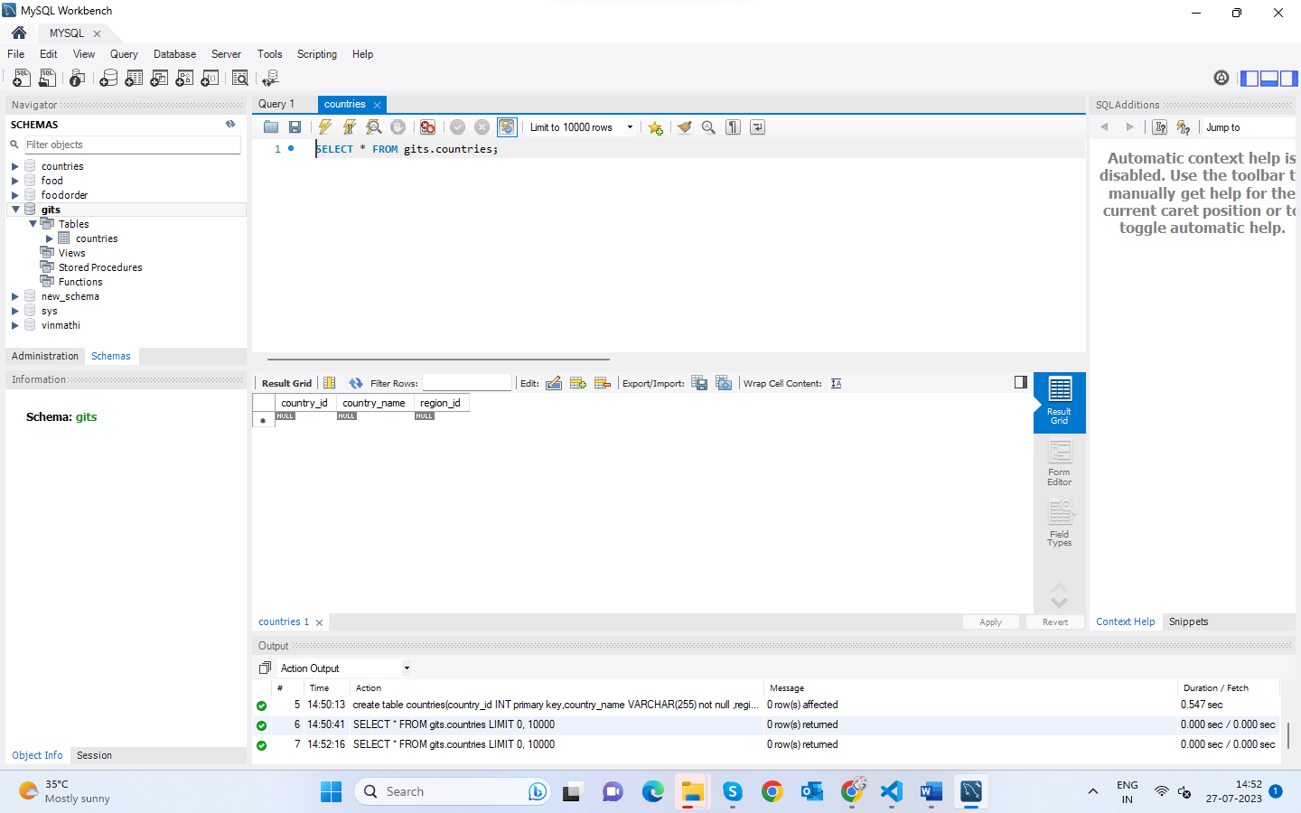

3. Write a SQL statement to create a table named jobs including columns job_id, job_title, min_salary, and max_salary, and make sure that the default value for job_title is blank and min_salary is 8000 and max_salary is NULL will be entered automatically at the time of insertion if no value assigned for the specified columns.

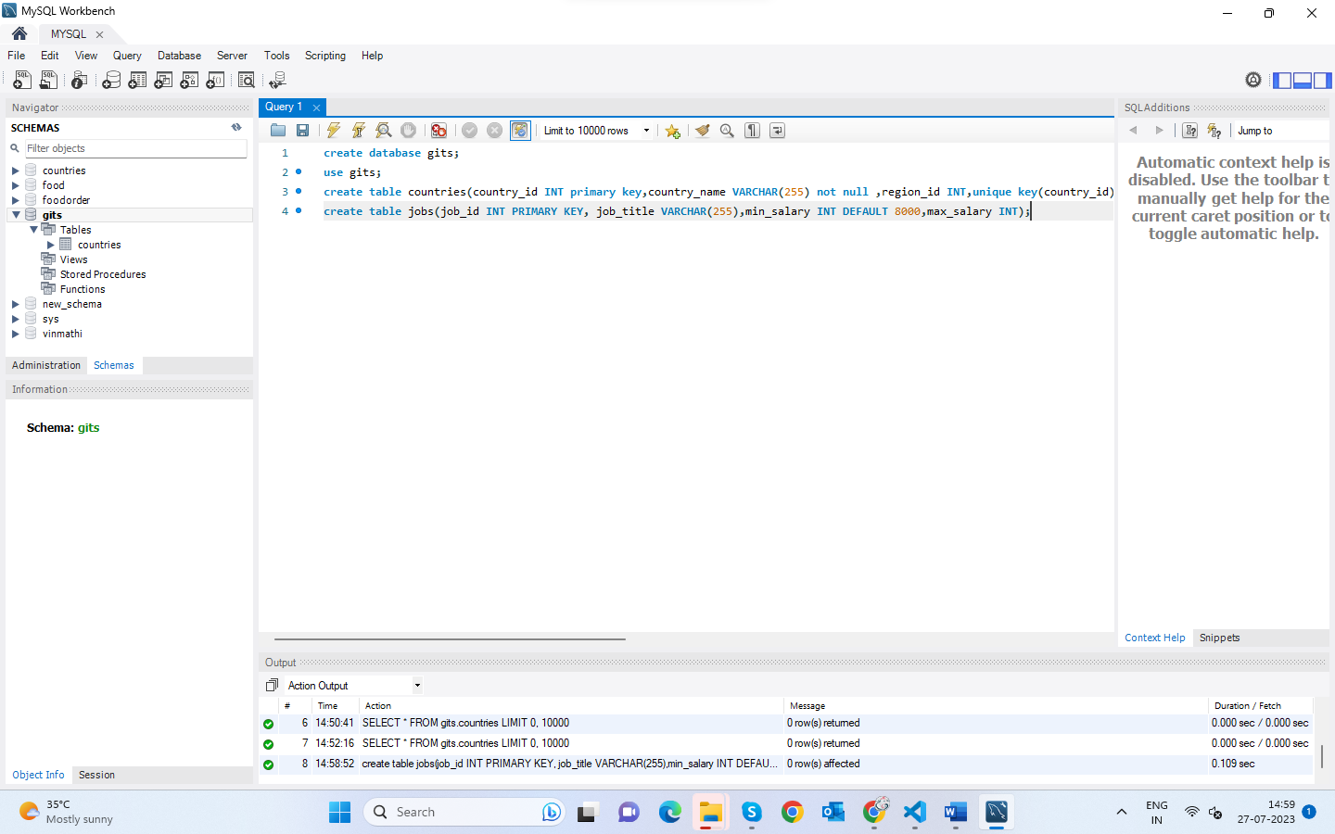

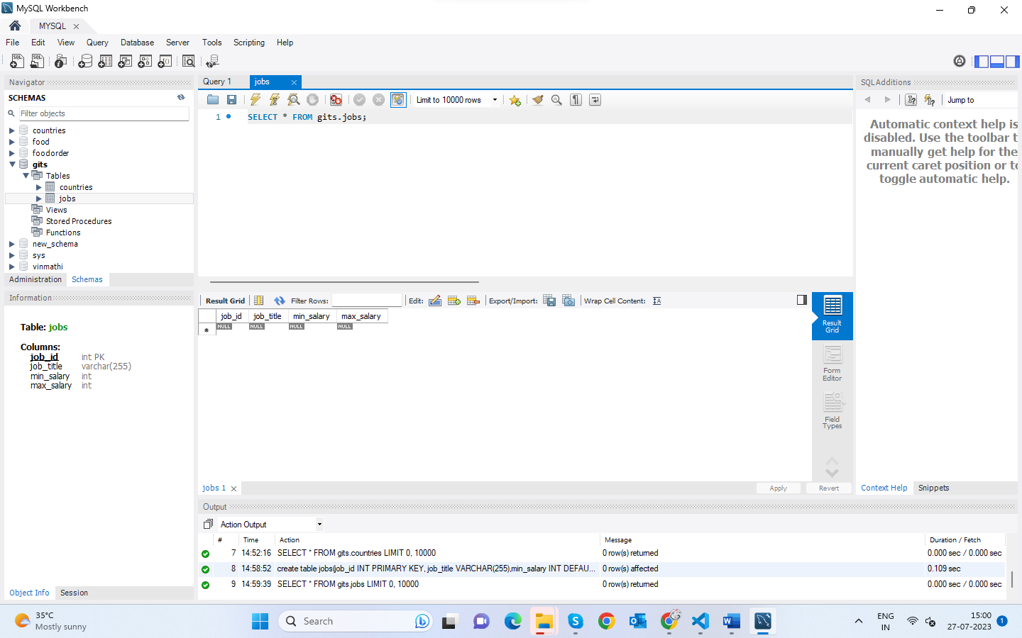

4.Write a SQL statement to create a table employee including columns employee_id, first_name, last_name, email, phone_number hire_date, job_id, salary, commission, manager_id, and department_id .

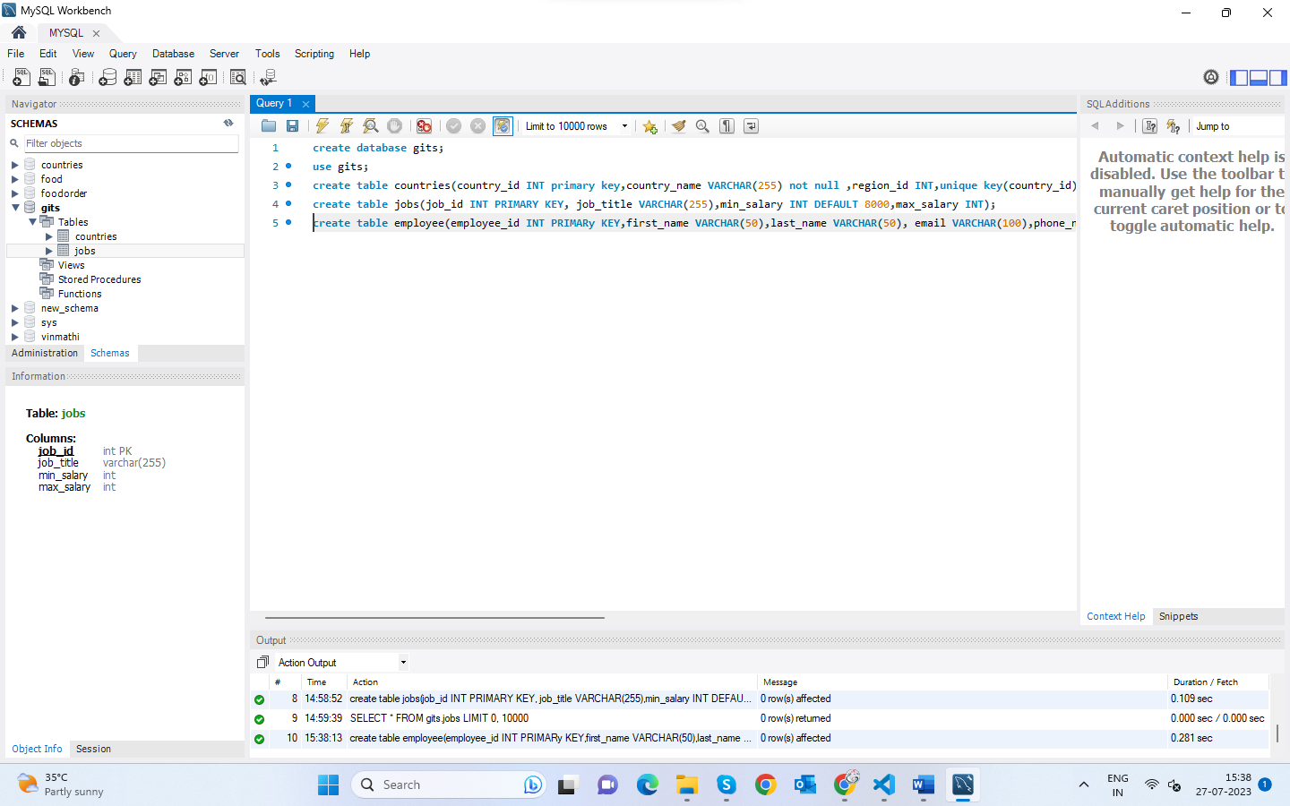

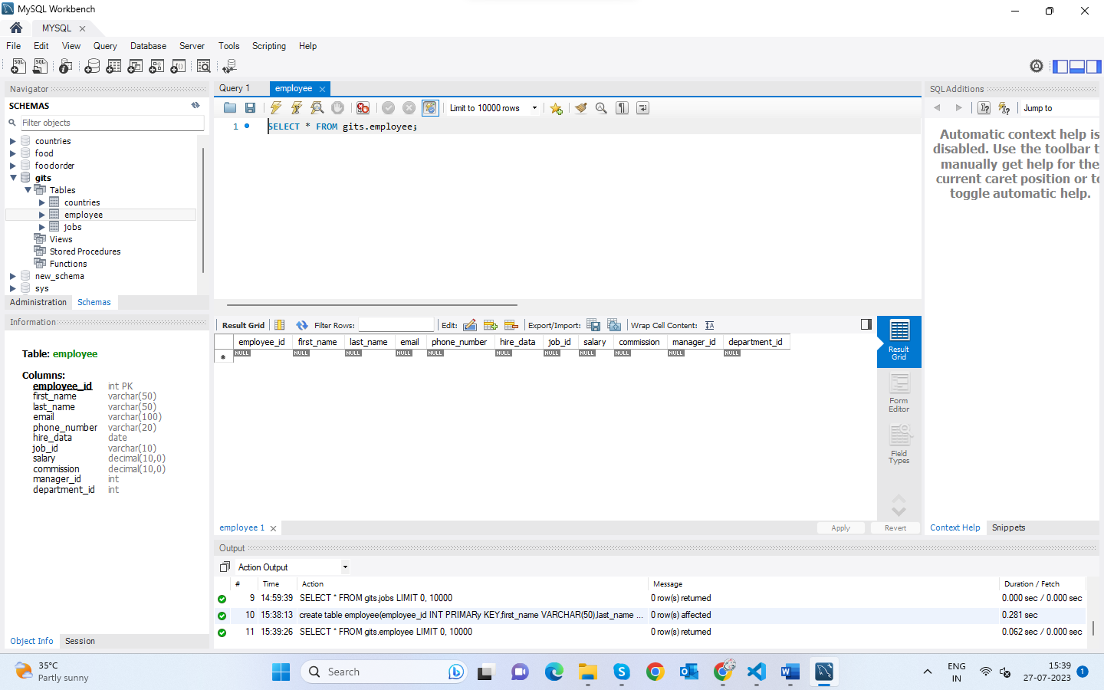

5. Write a SQL statement to insert a record with your own value into the table countries against each column.

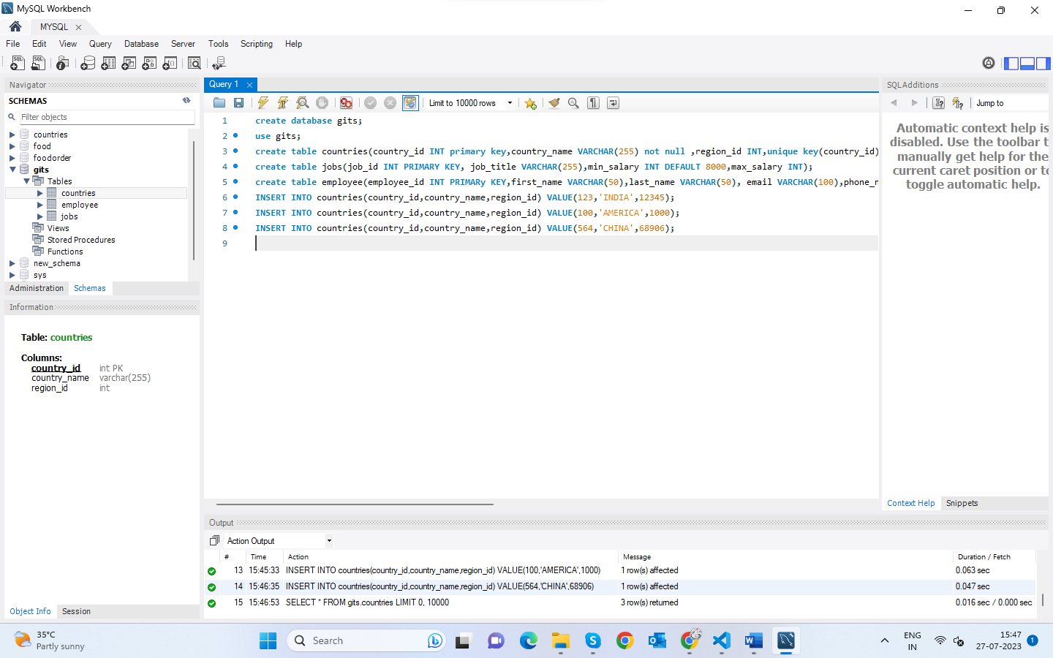

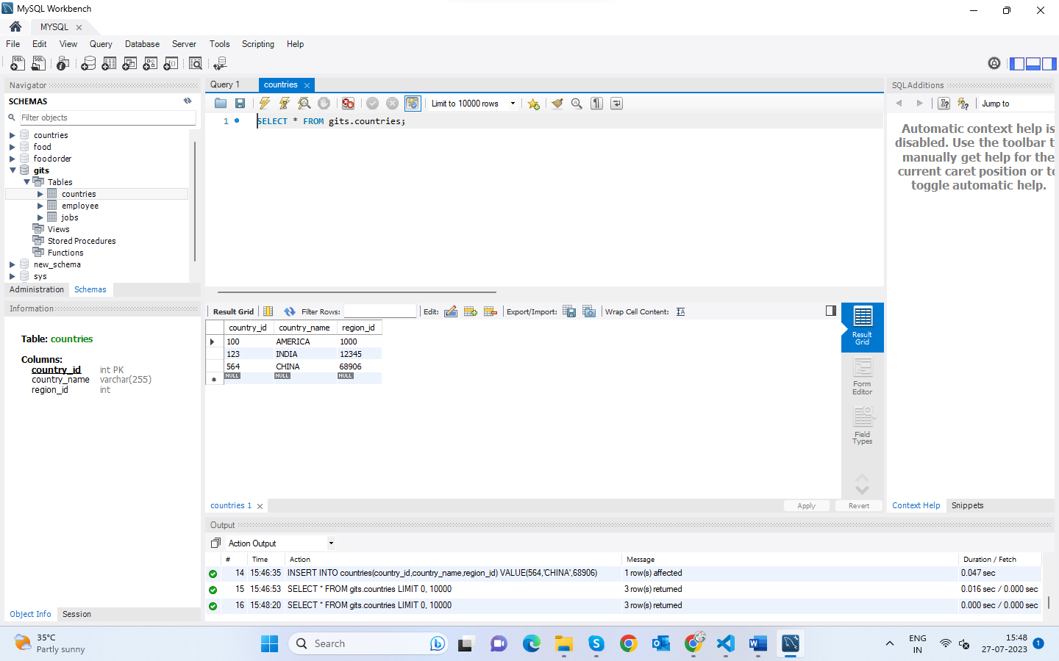

6. Write a SQL statement to insert a record with your own value into the table jobs against each column.

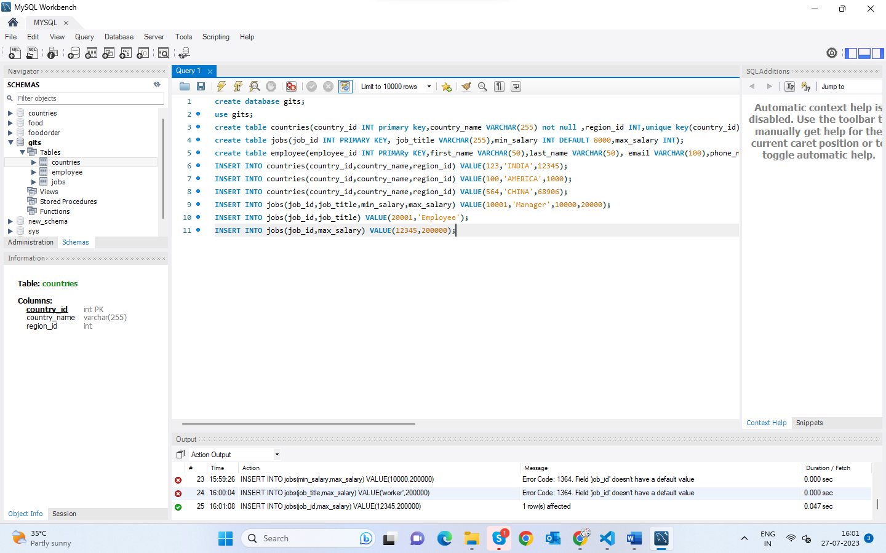

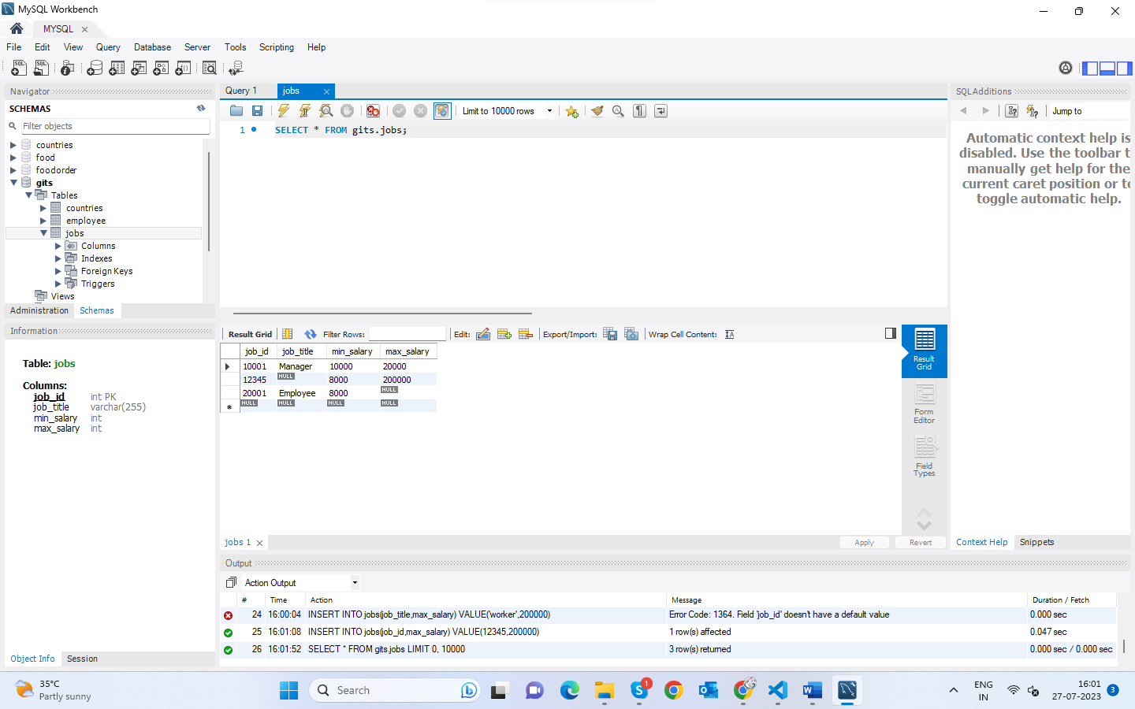

7. Write a SQL statement to insert one row in the jobs table to ensure that no duplicate value will be entered in the job_id column.

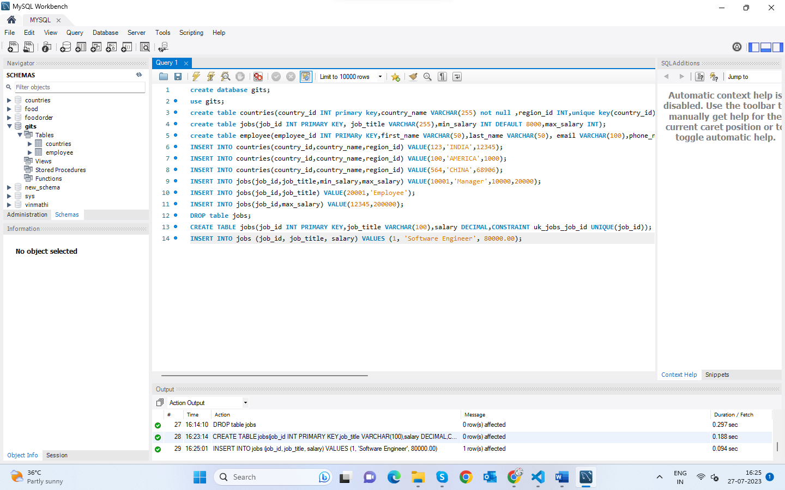

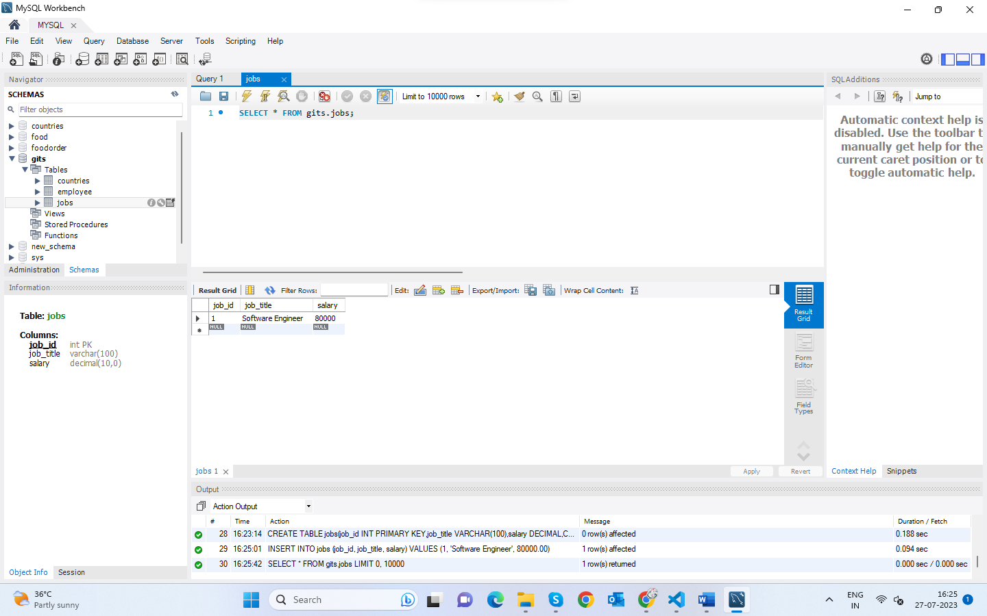

8.Write a SQL statement to rename the table countries to country_new.

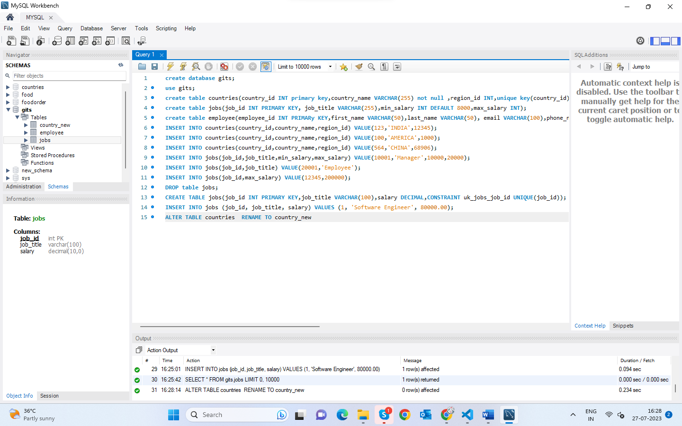

9.Write a query to display the names (country_id, country_name) using alias name “Country ID", "Country Name"

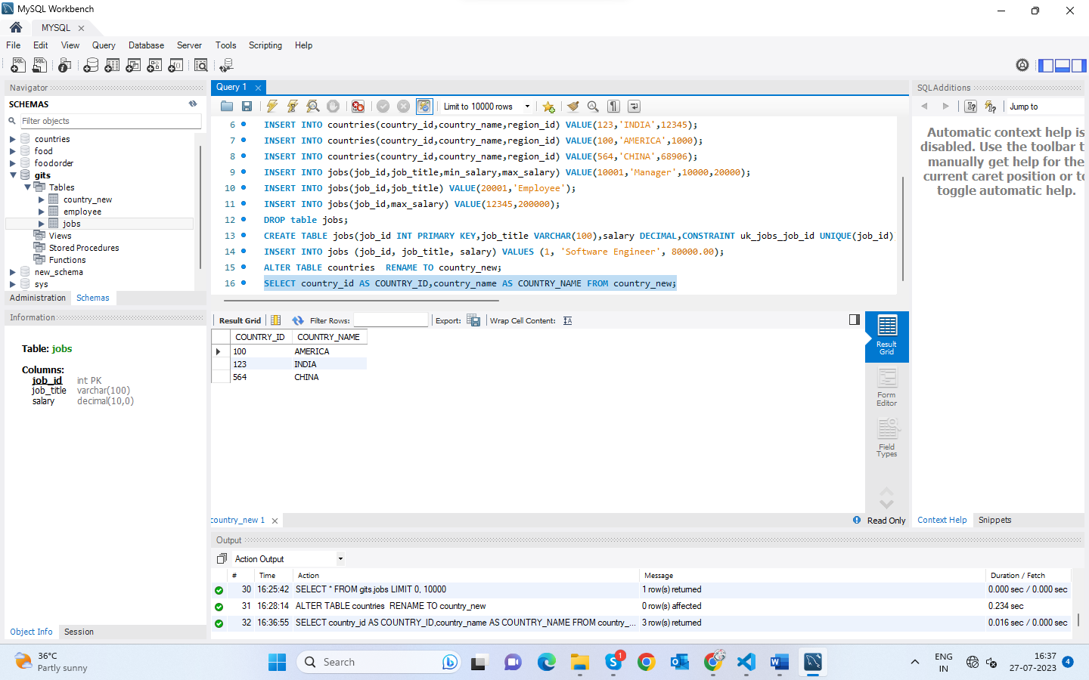

10.Write a query to get all country details from the countries table order by country_name, descending.